

Lab Journal: 11
Date: 11/26/2025

Student : Lotfullah Muslimwal
Enrollment : 01-131232-039

Department of Software Engineering

Bahria University, Islamabad

Software Construction-Lab (Fall-2025)
Teacher: ENGR. SAAD MAZHAR

Task No: | Task Wise Marks |  | Documentation Marks |  | Total Marks  (20)
Task No: | Assigned | Obtained | Assigned | Obtained | Total Marks  (20)
1 | 3 |  | 5
2 | 3 |  | 5
3 | 3 |  | 5
4 | 3 |  | 5
5 | 3 |  | 5

Comments:

Signature

Lab 11 – Designing Classes - II

Lab Task:

You are to implement your own version of world-of-zuul.

• Follow all the concepts covered so in today’s lab and previous labs.

• Make sure all invalid commands are generate an error

• Follow High cohesion and loose coupling

• Refer to the exercises in Chapter 6 of the BlueJ book for guidance regarding this implementation.

Code of Lab: Available in the Github
Link to the Code
Link to the Main Class

Screenshot
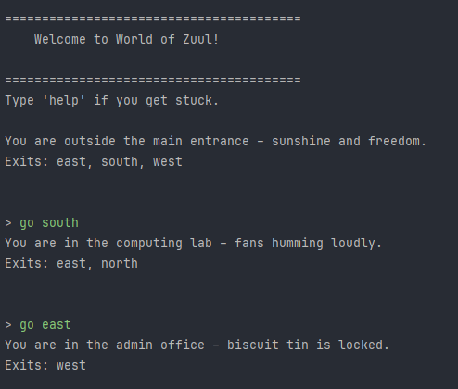

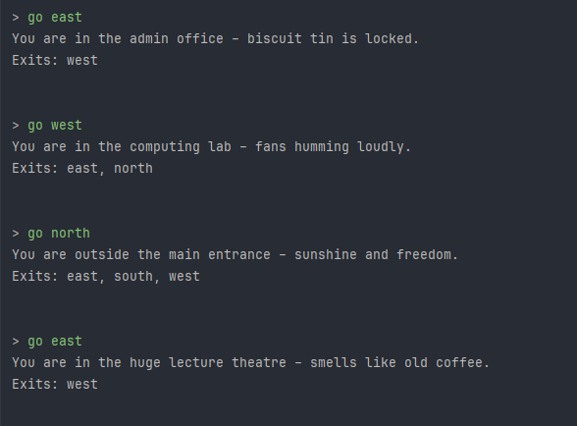
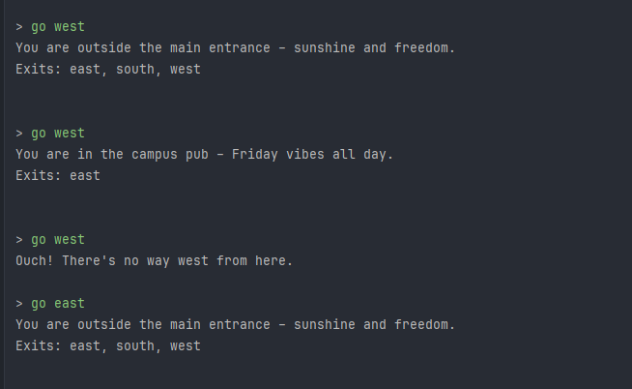

Conclusion
In this lab I learned that good design isn’t about making the game fancier; it’s about keeping every class small, giving it one clear job, and making sure classes don’t mess with each other too much. My new version of Zuul is still the same little adventure, but the code feels tidy, easy to read, and really simple to change or add new stuff to. I finally get why high cohesion and low coupling matter; it just makes life so much easier. Happy with how it turned out!

